K Bharath Sanjay
192512324

Exp No: 15 EMBEDDED C PROGRAM TO CONVERT THE HEXADECIMAL DATA 0XCFH TO DECIMAL AND DISPLAY THE DIGITS ON PORTS P0, P1 AND P2
AIM:
To write an Embedded C program to convert Hexadecimal numbers into Decimal and display the digits on ports using Keil software.
SOFTWARE REQUIRED:
• Keil software
PROGRAM:
#include <reg51.h>
void main(void)
{
unsigned char hexa = 0x08;
unsigned char hundreds, tens, units;
ACC = hexa;
B = 10;
ACC = ACC / B;
units = B;
B = 10;
ACC = ACC / B;
tens = B;
hundreds = ACC;
P0 = units;
P1 = tens;
P2 = hundreds;
while(1);
}
OUTPUT:
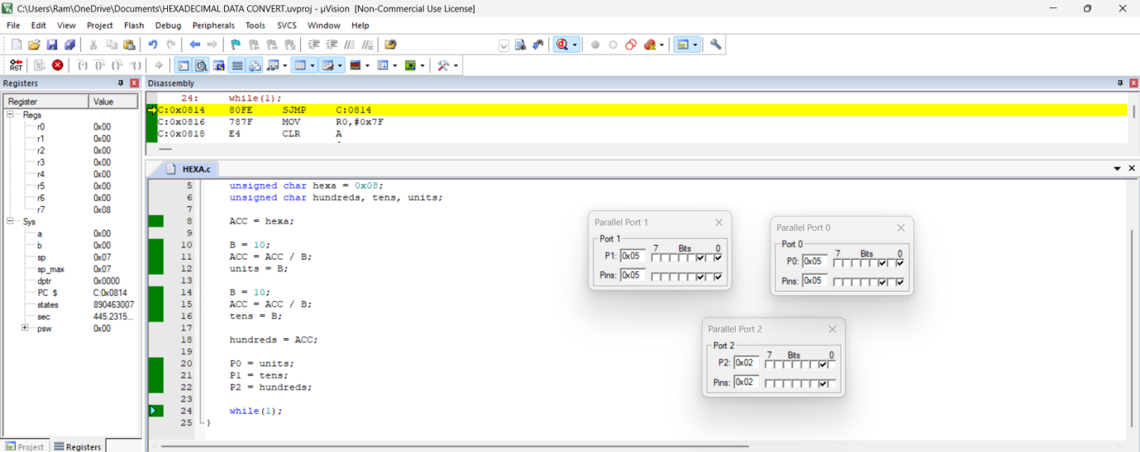
RESULT: Thus the program has been successfully verified and executed.

